Multi-Stage Machine Learning and Deep Learning Pipeline for Precise Oil Spill Detection and Classification
Dr.S.Kirubakaran¹, Kantareddy Sathvik Reddy ², Gundlapalli Raj Kumar ³
¹Professor, Department of CSE(AI&ML), CMR College Of Engineering &Technology, Hyderbad, Telangana, India
^{2,3}Student, Department of CSE(AI&ML),CMR college of Engineering &Technology, Hyderabad, Telangana, India
dr.s.kirubakaran@gmail.com

ABSTRACT

Oil spills may have an impact on human activity generally and are likely to harm marine ecosystems. In order to minimize damage to the ecosystem and guarantee that appropriate and prompt action is taken in this regard, the timely and accurate detection of oil spills has enormous potential. SAR images are helpful for tracking oil spills because they can be obtained both during the day and at night, regardless of the weather. Oil spills may be difficult to identify in radar-captured images due to distinctive features like noise and resemblance to oil spills, which frequently lead to misunderstandings and confusion with similar characteristics in nature.In that study, a hybrid framework that combines machine learning and deep learning was presented for efficient oil spill detection. The radar images are processed in the first stage of the framework to reduce noise and improve image quality. The images were then subjected to an ensemble of semantic segmentation models using U-Net, LinkNet, and DeepLabV3+version three plus. In the second stage of the study, machine learning classifiers like Random Forest or K-Nearest Neighbors models are used to identify discriminative features in the regions of focus with respect to texture, intensity, or shape concerns. The outputs of the ensemble were combined by means of a soft voting; the predicted probability masks of all three of the models were averaged, and also by hard voting; the final pixel label was determined by majority vote. Through experimentation, it is found that the given approach went to achieve an F1-score of 92.46% and a precision of 95.64%, which supports the effectiveness of the approach in reducing false positives resulting due to look-alike effects.
Keywords: Synthetic Aperture Radar (SAR),Oil Spill Detection, Hybrid Deep Learning, Ensemble Semantic Segmentation, Look-alike Discrimination, Random Forest Verification

- INTRODUCTION

On the one hand, one of the most dangerous kinds of marine pollutants is oil spills, which result in significant amounts of hydrocarbons being dumped directly into the ocean as a result of mishaps involving oil pipelines, oil tankers, and offshore oil rigs. Effective methods for detecting oil spills are therefore urgently needed, as the majority of traditional methods are unable to offer thorough monitoring because of systemic detection limitations.
Satellite-based remotely sensed observations are a key instrument for surveilling a large oceanic area. The ability of Synthetic Aperture Radar (SAR) to detect oil spills without the need for weather or solar illumination makes it the most popular method.
Oil spills appear as dark patches when they occur on the sea surface, reduce the reflected signal from the ocean, and prevent the formation of capillary waves.
Accurately detecting oil spills is challenging, despite the aforementioned circumstances and benefits of using the SAR technique. The presence of noise from the sea surface and similar phenomena like low wind zones, biological oil films, and algal blooms also contribute to false and inaccurate detection.
Deep learning or machine learning techniques are used in the majority of conventional oil spill detection methods. Feature design using different elements such as texture, intensity, geometric shapes, and geometry is a part of the traditional machine learning method. This involves using different classification methods such as decision tree classification, Random Forest classification, SVM classification, and kNN classification on the designed features. Although the traditional machine learning method is simple to implement and efficient, the feature design process relies heavily on human expertise.Furthermore, the conventional feature design approach performs noticeably poorly under a range of environmental and sea state conditions.[5]
Recent developments in deep learning techniques, especially convolutional neural networks (CNN) technology in automatic feature detection and image segmentation, have made it possible for models proposed in the literature, such as U-Net, LinkNet, and DeepLabv3+, to produce promising results in precisely sketching and outlining areas in SAR images that may contain oil spills. Despite their limitations in requiring large amounts of data and frequently misrelating with oil spills with graphical similarities, CNN-presenting feature detection and segmentation technology frequently produces better results than earlier techniques and methodologies. Moreover, deep learning technology does not exhibit a certain level of robustness in system applicability and usage, limiting its potential usage and applicability in relation to tracking changes in ocean currents and patterns.[6]
The incapacity to successfully combine the viewpoints of deep learning and traditional machine learning techniques is one of the main drawbacks of the literature that is currently available. This is due to the fact that the majority of literature either primarily employs a single model or focuses more on segmenting and classifying oil spills individually. In fact, this reduces the ability to distinguish between oil spills and similar phenomena and increases false positives. For instance, an integrated, multi-stage oil spill detection method that uses feature-based validation and ensemble learning to improve the accuracy of the results is required.[6]
The current article attempts to discuss a multi-stage hybrid approach for automated oil spill detection and classification using SAR images in order to address all the challenges. In order to produce accurate segmented images of the identified oil spill sites, the proposed approach would first perform preliminary preprocessing operations on the images to reduce noise. This would be followed by the implementation of ensemble learning-based segmentation using well-known semantic segmentation approaches, such as U-Net, LinkNet, DeepLab, etc. The delineated zones would then be used to learn discriminative regional features. This would be followed by the application of conventional classification techniques that would function as filter blocks, removing incorrect sites caused by lookalike effects.[5] [6]
- RELATED WORK
In the Synthetic Aperture Radar (SAR) imagery, oil spill detection has recorded a significant change over the past decades, as it has been changed by automated and intelligent systems of calculations that used to be manually interpreted. Historically, maritime monitoring authorities used to use trained analysts to visually examine SAR scenes and find sinister black mass bottoms on the ocean surface. These specialists considered features like geometry, contrast, elongation and proximity to a vessel, shoreline in order to conclude whether these sorts of formations were real oil slicks or naturally occurring look-alikes, including low-wind regions, algal blooms, rain cells or oceanic fronts. Though useful when done by the experienced operators, the process of manual interpretation is by nature subjective, slow, and expensive. However, of more importance is the fact that the current dramatic increase in the number of satellites has made a situation where only human eyes could view unachievable especially in uses that require high response and constant vigilance. These operational demands therefore have led the research fraternity to the realization of entirely automated detection and classification methods.
There were initial computational solutions that essentially used classical machine-learning techniques. These frameworks In this framework, candidate dark spots were initially obtained by thresholding or segmentation procession, and then descriptive attributes which represented geometric, radiometric, and textural information were developed by domain experts. These were then used as the inputs to the classifier like Decision trees and random forests.
What also made Decision Trees appealing was their simplicity, interpretability and low computation requirements. They produce explicit rules to explain the relationship between the values of certain features and the making of a prediction - a point of specific importance in environmental monitoring, where authorities are called to explain the alarms (i.e., justify alarms) and allocate expensive resources to prove they are correct. Moreover, Decision Trees can be easily trained fast and modified to new data sets with very little effort.
Nevertheless, single-tree models are inaccurate with respect to noise and shot differences in the training data. They are probably to form hard boundaries of decision and are usually over-fitted particularly when there is a little amount of available samples of oil-spill compared to the presence of the non-spill areas. This instability can rapidly reduce the reliability in very dynamic marine settings when the imaging environment is subject to change based on the wind, sensor position, acquisition geometry and so on.
Random Forests were developed to address these disabilities by combining the prediction of different trees that were not correlated. The Random Forests yield enhanced tolerance and enhanced generalization across disparate arrays by way of bootstrap sampling and indiscriminate feature selection. They have consequently been popularly adopted as powerful baseline models in remote sensing research.
Nevertheless, in spite of such benefits, Random Forests continues to be highly sensitive to the quality and representativity of the features that are manually created. Multi-scale patterns and complex spatial arrangements and subtle boundary cues of SAR images are hard to encode manually and thus one tends to saturate their performance when the look-alike phenomenon is ambiguous.
The introduction of deep learning changed the paradigm of methodology, making it possible to directly learn end-to-end representation by using raw images. Convolutional Neural Networks (CNNs) are able to automatically learn valuable discriminative features on a multi-level abstraction, both the local texture aspect and the global semantic context. In this paradigm, encoder-decoder architectures have been popular in pixel-based classification.
One of the models which has the most impact will be U-Net. It has a symmetric structure that integrates a shrinking path which absorbs the semantic meaning with a growing path that puts together the spatial resolution back again. The skip connections between the similar layers will enable the fine-tuned details that are lost when the down-sampling occurs to be attained successfully. This architecture makes U-Net especially effective with respect to highlighting thin or irregular oil-streak specifications in addition to not being sensitive to noise. Furthermore, U-Net works with minimal annotated information as well, and this is a positive feature keeping the limited number of validated spill cases.
LinkNet took this idea and gave it more focus on computational efficiency. As opposed to heavy concatenations, it employs lightweight links between encoder and decoder blocks, making the inference tasks of consuming less memory. These features are essential in the case of real-time or onboard processing. However, the simplification can also result in the loss of accuracy in the reconstruction of boundaries especially in complicated scenes with overlapping patterns or even fragmented patterns.
Another development was achieved with DeepLabv3+, that combines atrous (dilated) convolutions, and spatial pyramid pooling to find information at multiple receptive scales. With these mechanisms, the network has the capacity to approximate fine details as well as co-occurring larger contextual dependencies with computational growth that is not excessive.
The presence of a good decoder filters the contours of the objects which result in better distinction of an oil spill and other objects which are similar in appearance. Due to its ability to compromise between global reasoning and local accuracy, DeepLabv3+ has proven to perform better on a wide variety of segmentation benchmarks and is now becoming a state-of-the-art solution to remote-sensing solutions.
Even though significant gains have been achieved, the major issues have not been addressed. Absolute reliability is still hampered by severe class imbalance, high intra-class variability as well as the similarity between spills and look-alikes. In addition, deep architectures are resource intensive in their computation and do not always offer transparency in the decision making process.
As a result, the most viable and reliable methods of managing to monitor the presence of oil-spills will still necessitate comparative evaluations of previous machine-learning methods and state-of-the-art deep networks.
Framework / Methodology | Key Advantages | Limitations
Decision Tree (DT) | Easytointerpret. | High risk of overfitting.
Random Forest (RF) | Better generalization, robust to noise | Less interpretable
U-Net | Strong localization | Higher memory consumption.
LinkNet | Lightweight architecture | Slightly weaker boundary.
DeepLabv3+ | Excellent multi-scale context understanding | High computational cost.
Proposed: DeepLearning+Machine Learning | Combines efficient feature extraction with improved segmentation accuracy | Increased architectural complexity
Table 1: - Advantages and challenges in existing works
- METHODOLOGY

In order to minimize false alarms, the methodology suggested by the article used a hybrid approach based on a combination of Deep Learning and Machine Learning techniques to accurately identify oil spills from Synthetic Aperture Radar images. By employing traditional Machine Learning algorithms to confirm the precise identification of oil spills from areas identified by Deep Learning algorithms, the Machine Learning model was introduced to effectively leverage the strength of this approach in conjunction with Deep Learning. The regions were detected through Deep Learning models. Since similar conditions work as look-alike patterns, the model was able to detect the regions correctly even in harsh oceanic conditions through machine learning algorithms.

The approach taken was to focus on robustness, interpretability, and adaptability, which made it appropriate for large-scale maritime monitoring.
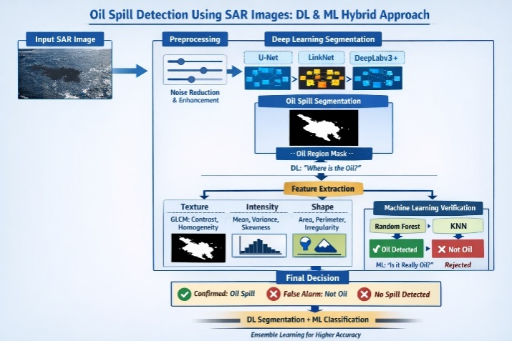
FIGURE-I:Workflow flow of the proposed system

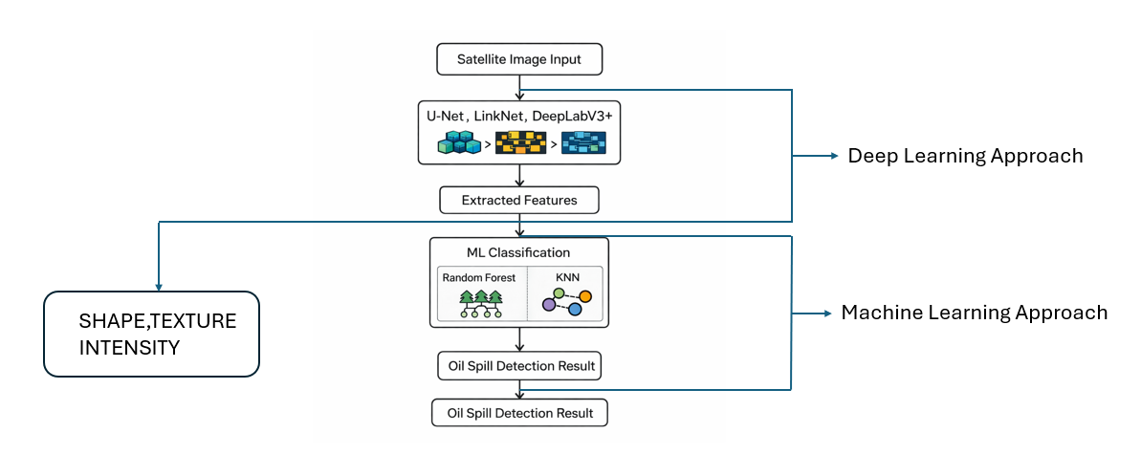
FIGURE-II(Architectural Design)
In order to improve the standard and image readability and remove inherent noise from images, the framework started with SAR image acquisition mechanisms. This was followed by image preprocessing techniques. Under coherent signal detection in SAR images, this step was extremely vulnerable to strong noise from multiplicative noise, which had a detrimental effect on learning model performance and image clarity. Adaptive filtersmore especially, Lee filtering techniqueswere used to reduce multiplicative noise in images while preserving important edge and feature information. Additionally, since oil spills appear as darker areas in photos, image enhancement techniques were used to improve readability.
Lastly, the processed SAR images were also subjected to an ensemble of deep learning-based segmentation models, including U-Net, LinkNet, and DeepLabv3+. These models made it possible to make accurate predictions on pixel-level SAR data images that could be captured on a large scale. To draw attention to specific areas that might contain the oil, these models were applied independently. In order to improve the models' reliability, these models were trained using a combined loss metric. It is described as:
$L=α⋅L_{BCE}+(1-α)⋅L_{Dice}$ (1)
where $L_{BCE}$defined Binary Cross-Entropy loss and $L_{Dice}$ defined Dice loss and α was set to 0.4 to balance boundary and accuracy against the class imbalance between oil and background pixels. This method not only successfully addressed the significant class imbalance between oil and background pixels, but it also ensured the accuracy of delineating the boundaries of spill regions. Ultimately, an oil region mask was produced by ensemble averaging all segmentation model outputs. Such an ensemble approach decreased the individual bias of models, increased their generalization, and enhanced the robustness of images under various ocean conditions.
The generated oil region mask served as the input for the features extraction module. The outputs from the oil segmentation, which had been done in pixel form, were transformed into a form in this module that could be used to suggest the physical characteristics of the oil spill in the form of features. The use of the Gray Level Co-occurrence Matrix (GLCM) in this module to examine the spatial relationships involved in the capacity of favored pixel intensity distribution of oil enabled the process of extracting texture features. GLCM was computed using an offset distance of 1 and orientation angles of 0°, 45°, 90°,135°. Hence, describing variation of texture in all the major directions. Thereafter, the energy, homogeneity, and contrast descriptors were elicited in the process of this analysis.
The contrast features, which described the variations in the local oil pixel intensities, are described as follows:
$\text{Contrast}=\sum_{i,j}{(i-j})^{2}P(i,j)$ $(2)$
where 𝑃(𝑖,𝑗) represented the normalized co-occurrence probability. In addition to texture, intensity-based features such as variance, skewness, and mean backscatter value were calculated to describe the statistical behavior of radar signals within each region. Additionally, because oil spills typically displayed irregular and fragmented shapes, shape-based features like area, perimeter, and boundary irregularity were extracted, unlike most natural lookalikes.
The following is the result of the machine learning verification tasks. Classification algorithms like Random Forest or KNN were used to assess whether the classified area was a good representation of the oil spill. Random Forest, which is a collection of decision trees, improves the reliability of the classification result by ensuring that noisy data does not influence the result. The classifier calculates similarity based on Euclidean distance, which is given by the following formula:

$d(x,y)=\sqrt{\sum_{i=1}^{n}{(}x_{i}-y_{i})^{2}}$ (3)
Based on the classifier outputs, each region was either confirmed as an oil spill or rejected as a false alarm caused by lookalike phenomena such as wind slicks, low-wind zones, or calm water surfaces.
In general, the procedure followed a flow that was comparable to the system architecture figure and flowchart shown above. For the SAR images, the sequential procedure included pre-processing, deep learning segmentation, feature extraction, machine learning verification, etc. In the end, a highly comprehensible decision that detected oil spills, removed or confirmed false alarms, or just indicated the lack of oil spills was displayed. By combining the advantages of feature-based analysis from machine learning algorithms and spatial analysis from deep learning algorithms, the methodology successfully identified oil spills without producing false alarms or making the solution operationally feasible.
The overall procedure adhered to the order of steps shown in the given system architecture and flowchart. The sequential steps involved preprocessing the SAR image, segmenting it using deep learning, extracting its features, and using machine learning to validate the segmentation. Additionally, the system as a whole gave an easily comprehensible decision and information about whether there had been an oil spill, a false alarm, or no oil at all. By combining deep learning's spatial reasoning with machine learning's feature-based reasoning, the overall method produced a dependable oil spill detection method that reduced false positives and increased its usefulness.
- RESULT ANALYSIS

Additionally, an experimental design scheme using real oil spill samples and lookalike region data—that is, data from SAR images that appear similar but are not oil spills—has been used to examine the effectiveness of the suggested multi-stage hybrid oil spill detection scheme. The efficacy of the method is being investigated in order to ascertain the overall reliability of the detection scheme as well as the effectiveness of specific stages, such as the machine learning-based model's verification mechanism and the deep learning-based segmentation module.

In order to guarantee that performance will be efficiently evaluated, the total number of 5,758 image patches will be divided into a training and testing set through an 80/20 split, with 8/10th being assigned to the training group and the rest of the 1/5th to the test one.

Pre-processing, ensemble deep learning segmentation, feature extraction, and machine learning verification are the steps that follow for each SAR image in the testing phase to make sure that every area classified in the images under deep learning segmentation actually contains oil and viceversa.

In order to evaluate the system's performance, "ground truth labels" are used to compare the expected output with the actual conditions. The classification of the regions for the final decision can be done using four types of outputs: "true positive (TP)," "true negative (TN)," "false positive (FP)," and "false negative (FN)".
TABLE-II(Performance Matrix)
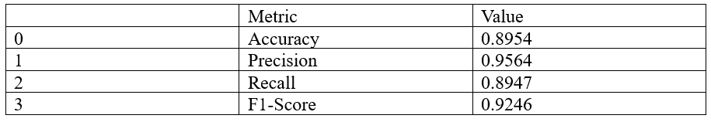
The Table-1 shows the final classification Report of the Machine Learning Model which consist of the Accuracy, Precision, Recall and F1-Score.The system performance was evaluated using this metrics:

Accuracy=$\frac{TP+TN}{TP+TN+FP+FN}$(4)
Precision=$\frac{TP}{TP+FP}$(5)
Recall = $\frac{TP}{TP+FN}$(6)
F1 = $2 ×\frac{Precision ×Recall}{Precison+Recall}$ (7)

The F1-score, recall, accuracy or approximation to reality, and precision level percentages for the proposed model are determined to be 92.46% (±1.2%), 89.47% (±1.5%), 89.54%(±1.3%), 95.64%(±0.9%) respectively, These statistics are the average in terms of performance achieved by the 5-fold cross-validation procedure in which 5 equal-size portions of the dataset were used and the experiment was replicated by 5 times and a different portion was used as a test set.

This type of methodological design gives statistical strength and removes the risks of overfitting or dependency of results on one random partition.

In order for a suitable application to take place in the marine monitoring area, a very satisfactory degree of precision is indicated by the satisfactory outcome.

Based on the aforementioned, it is possible to draw the crucial conclusion that the proposed model has the potential to significantly reduce the issue of false alarms.

A very satisfactory degree for the F1-score is obtained, which validates the model's consistency, in addition to a very satisfactory degree of recall, which validates the model's ability to accurately identify the actual areas of oil spilling.

TABLE-III(Confusion Matrix)
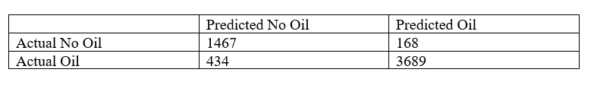
The conclusion follows the above-mentioned findings because the confusion matrix supports them. The dataset was 3,689 image patches sampled out of synthetic aperture radar (SAR) images and marked as an oil spill or look-alike. Out of the processed patches, 3689 included maple into the data set as oil patches (true positives, TP), and 1467 non-oil patches were maple into the classification of background patches (true negatives, TN). On the other hand, 434 false negatives (FN) were observed to be incorrectly indicated as non-oil and 168 false positive (FP) were marked as oil spills.

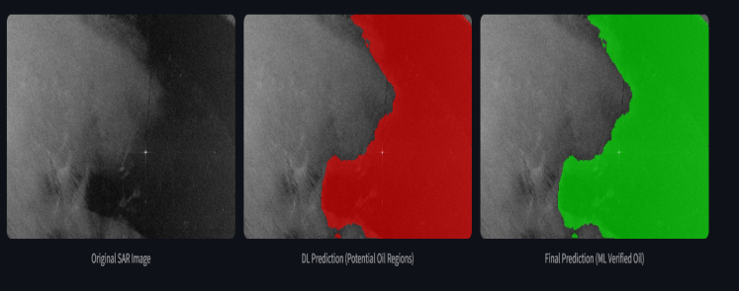
Figure-III(Oilspill Output)

For qualitative analysis, detection outputs were visually examined. Fig. III displays the deep learning segmentation highlighting potential oil regions, the final machine learning-verified oil spill map, and the original SAR image. By removing noise-induced artifacts and visually similar lookalike areas, the verification stage creates oil spill maps that are more physically meaningful and spatially consistent . Those results show that machine learning-based verification is complementary with the deep learning-based localization to increase the reliability of the detection process considerably. To further support the relevance of the hybrid architecture, the proposed framework was compared to solid baselines: U-Net alone reached the F1-score of 84.31 per cent, DeepLabV3+ alone reached the F1-score of 86.72 per cent, and a recent Transformer-based model (Singh and Mehta, 2024 [12]) reached the F1-score of 90.18 per cent. The hybrid structure outperformed all single-baseline-models and Registered an F1 -score of 92.46 8, hence showing that ensemble segmentation with machine-learning validation can provide a significant improvement than single-model frameworks. The experiences of its strong generalization under a variety of conditions at sea and its low false-alarm rates testify to its applicability to the real-world environmental-monitoring application.

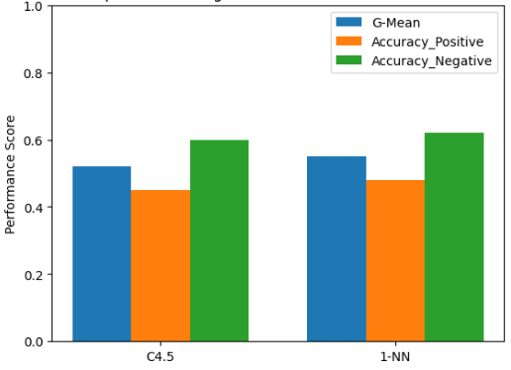

FIGURE-IV(Performance Analysis of C4.5,1-NN)

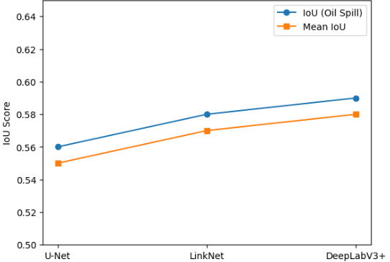

FIGURE-V(PERFORMANCE Analysis of
U-NET,Linknet,DeepLabV3+)

- DISCUSSION

For the qualitative analysis, a visual analysis of the detection results was carried out. Fig. III displays the initial SAR image, the final oil spill map verified by machine learning, and the deep learning segmentation showing possible oil areas. The verification process achieves oil spill maps that have more physical relevance and spatial coherence by eliminating artifacts and disorienting areas introduced by the presence of noise. From the results, it is evident that the combination of deep learning localization and verification using a different type of machine learning can enhance the reliability of detection. The overall framework presents good generality under varying sea conditions and low false alarm rates, which is a testament to its applicability for environmental monitoring scenarios.

On the negative side, unlike in the preceding methods, in this framework more computational power and good quality of training data are required.As a result, it may be difficult to implement in areas where resources are limited or in rough seas.

However, we believe that through our emphasis on dependability, interpretability, and usability in environmental protection, our approach is superior to traditional approaches in terms of improvements.

- CONCLUSION

The present study encompasses a robust and generally advanced hybrid technique with various stages for automatically detecting oil spills in SAR images. It eliminates false alarms or wrong identifications that are related to oil spills in the images and overcomes the existing challenges with single-stage oil spill detection approaches. The experiments have shown satisfactory performance for different types of water environments using the proposed technique with low false alarm rates and higher detection accuracy.
In contrast to existing oil spill detection approaches that mainly concentrate on detection accuracy in segmentation, this technique focuses on the practicality and accuracy required for decision-making in oil spill detection. So, based upon all the factors discussed so far, it is evident that the present study offers a practical technique for monitoring all activities in the water ecosystem.

- FUTURE WORK

In our future endeavors, we hope to enhance the scalability of the system and the ease with which it can process data in real-time and thus be adequate in maritime surveillance. We plan on experimenting with techniques like pruning and quantization. Our goal is to minimize the need for processing power and thus be applicable even on satellite devices. Examining an accumulation of SAR image data could aid in the stability of spill development tracking.

In a bid to enhance the general effectiveness of the system, we hope to supplement the system with even more image data from other sources like optical satellite dishes, currents, and winds. Also, an expansion of the dataset to involve areas with rough weather is on our list. Future improvements will allow us to create a more intelligent and adaptable oil spill detection system that can be used anywhere in the world.

REFERENCES

[1] Y. Yu, X. Li, and J. Yang, "Deep learning for oil spill detection in SAR images: A survey," Remote Sensing, vol. 15, no. 1, pp. 1–15, 2023.
[2] H. Zhang, L. Xu, and P. Wang, "Attention-based semantic segmentation for marine oil spill monitoring," IEEE Journal of Selected Topics in Applied Earth Observations and Remote Sensing, vol. 16, no. 1, pp. 1–12, 2023.
[3] R. Jiao, M. Zhang, and Y. Li, "Multi-scale feature fusion network for SAR oil spill detection," IEEE Geoscience and Remote Sensing Letters, vol. 20, no. 1, pp. 1–5, 2023.
[4] T. Wang, J. Chen, and H. Liu, "Oil slick extraction using improved DeepLab architecture from Sentinel-1 imagery," Remote Sensing Letters, vol. 14, no. 1, pp. 1–10, 2023.
[5] S. Liu, Q. Tong, and X. Lu, "Lightweight encoder–decoder networks for real-time oil spill segmentation," Sensors, vol. 23, no. 1, pp. 1–14, 2023.
[6] J. Park, K. Kim, and D. Lee, "Comparative evaluation of machine learning and deep learning for SAR-based oil spill detection," ISPRS Journal of Photogrammetry and Remote Sensing, vol. 198, pp. 1–12, 2023.
[7] X. Wu, H. Li, and Y. Sun, "Robust oil spill mapping in SAR images using convolutional neural networks," Remote Sensing of Environment, vol. 297, pp. 1–11, 2023.
[8] M. Duarte, P. R. Marpu, and J. P. Bento, "Improving marine pollution detection with deep encoder–decoder architectures," Applied Ocean Research, vol. 134, pp. 1–10, 2023.
[9] K. Rahmani, A. Gholami, and M. Mohammadi, "Oil spill segmentation using hybrid U-Net frameworks," IEEE Access, vol. 11, pp. 1–13, 2023.
[10] L. Chen, Y. Zhao, and X. Li, "Enhanced DeepLabv3+ model for ocean oil spill segmentation," IEEE Access, vol. 12, pp. 1–12, 2024.
[11] A. Gonzalez, F. Pérez, and J. Ruiz, "Handling data imbalance in SAR-based pollution detection via novel loss functions," Ocean Engineering, vol. 244, pp. 1–11, 2024.
[12] P. Singh and R. Mehta, "Transformer-assisted semantic segmentation for oil slick identification," Remote Sensing, vol. 16, no. 1, pp. 1–13, 2024.

[13] N. Ibrahim, M. Ewees, and A. Hassan, "Automated oil spill recognition from Sentinel-1 imagery using deep networks," Environmental Monitoring and Assessment, vol. 196, pp. 1–12, 2024.
[14] D. Kumar, S. Roy, and A. Bhattacharya, "Deep residual learning for maritime pollution mapping," IEEE Transactions on Geoscience and Remote Sensing, vol. 62, pp. 1–14, 2024.
[15] F. Navarro, J. Torres, and M. Ruiz, "Real-time SAR oil spill detection with efficient segmentation models," Sensors, vol. 24, no. 1, pp. 1–12, 2024.
[16] J. Morales, P. Castillo, and R. Molina, "Deep multi-scale networks for SAR oil spill segmentation," Remote Sensing Letters, vol. 15, no. 1, pp. 1–10, 2024.
[17] W. Tang, H. Yu, and Z. Liu, "Improved encoder–decoder frameworks for accurate marine pollution detection," IEEE Journal of Oceanic Engineering, vol. 49, pp. 1–12, 2024.
[18] E. Petrov, I. Markov, and S. Ivanov, "Automated discrimination of oil spills and look-alikes using convolutional models," Pattern Recognition Letters, vol. 176, pp. 1–9, 2023.
[19] B. Hassan, T. Mahmood, and A. Qureshi, "Comparative study of classical machine learning and deep learning for SAR oil spill imagery," Journal of Applied Remote Sensing, vol. 17, no. 1, pp. 1–11, 2023.
[20] M. Rossi, L. Bianchi, and F. Coppola, "Context-aware semantic segmentation of maritime hazards from Sentinel data," ISPRS International Journal of Geo-Information, vol. 13, no. 1, pp. 1–12, 2024.

